**PIZZA SALES ANALYSIS SQL QUERIES**

**-- 1. KPIs**

**-- a. Total Revenue**

Select Sum(total_price) as Total_Revenue from pizza_sales;

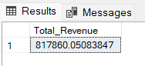

**-- b. Average Order Value**

Select (Sum(total_price) / Count(Distinct order_id)) as AVG_Order_Val

from pizza_sales;

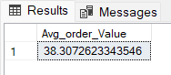

**-- c. Total Pizzas Sold**

Select Sum(quantity) as Total_Pizzas_Sold from pizza_sales;

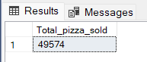

**-- d. Total Orders**

Select Count(Distinct order_id) as Total_Orders from pizza_sales;

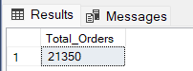

**-- e. Average Pizzas Per Order**

Select CAST( Cast(Sum(quantity) as Decimal(10,2)) /

Cast(Count(Distinct order_id) as Decimal(10,2)) AS Decimal (10,2))

from pizza_sales;

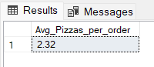

**-- 2. Daily Trends**

Select DATENAME(DW,order_date) as order_day, Count(distinct order_id) as Total_Orders

from pizza_sales

Group by DATENAME(DW,order_date);

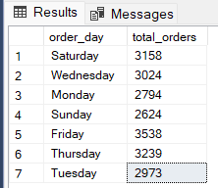

**-- 3. Hourly Trends for total order**

Select DATEPART(HOUR,order_time) as order_hours, Count(distinct order_id) as Total_Orders

from pizza_sales

Group by DATEPART(HOUR,order_time)

Order by 1 ASC;

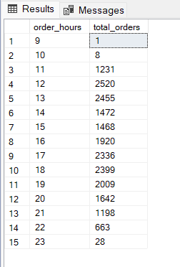

**-- 4. Percentage of sales by Pizza Category**

Select pizza_category , Cast(SUM(total_price)* 100 / (Select Sum(total_price) from pizza_sales) as decimal (10,2)) as PCT_sales

from pizza_sales

Group by pizza_category

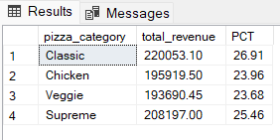

**-- 5. Percentage of sales by Pizza Size**

Select pizza_size, Cast(Sum(total_price) * 100 / (Select SUM(total_price) from pizza_sales) as decimal (10,2)) as PCT_sales

FROM pizza_sales

Group by pizza_size

order by pizza_size;

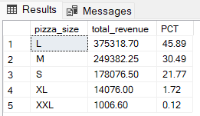

**-- 6. Total Pizzas Sold by Pizza Category**

Select pizza_category, Sum(quantity) as Pizza_Sold

from pizza_sales

group by pizza_category

ORDER BY Total_Quantity_Sold DESC

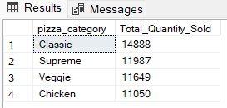

**-- 7. Top 5 Best Sellers by Pizzas Sold**

Select Top 5 pizza_name , Sum(quantity) as Pizza_Sold

from pizza_sales

group by pizza_name

Order By Sum(quantity) desc;

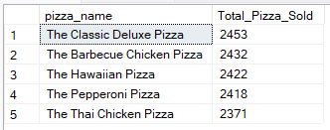

**-- 8. Bottom 5 Worst Sellers by Pizzas Sold**

Select Top 5 pizza_name , Sum(quantity) as Pizza_Sold

from pizza_sales

group by pizza_name

Order By Sum(quantity) ASC;

